**Guess the Number Game:  
Introduction:**

The Guess numbe Game is interactive game that challenges users and players to guess the randomly generated 4 digit number . in this assignment we employed the rules of TDD which is Test driven development to build and design a python based implementation of the game. the main goal of the game is to create interacive and engaging experience for players who are adhering to the best practices in software development through the application of TTD methods. The primary goal of the game is to develop python program to generate 4 digit number at random and interacts with the players to recieve their guesess. this program provides feedback to the player into the form of hints using circle and X symbol to indicate the accuracy of their guesess.

**Requirments:**

**1)** The program must generate a random four-digit number at the start of the game.

**2)** The program should prompt the player to input their four-digit guess.

3) After each guess, the program should provide hints based on the correctness of the guessed digits. A 'circle' symbol indicates a correct digit in the correct position.nAn 'x' symbol indicates a correct digit but in the wrong position

4) The player should be able to quit the game at any time by entering a q button

5) After a game ends (either through winning or quitting), the player should be prompted to play again or quit the program.

**Procedure:**

I embraced the Test-Driven Development (TDD) approach while crafting the game. This technique involves designing tests to outline the desired functionalities prior to creating the actual code. Consequently, the code is methodically built and enhanced to satisfy these test criteria. To achieve this, I utilized the pytest framework to construct and automate the execution of unit tests.

Set up a Git repository dedicated to the project and initiate a new Python file to start building the game implementation.

to start with these are the following steps to follow the procedure.

**Random Numbers Generation :**

to start the python code with i firstly started by creating test to make sure random number generated with four digits>

below is the code of function:

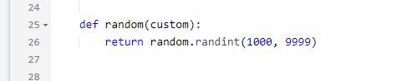

**user digits comparision and guesss:**

i have written test case to handle player input and validate guesses.

below is the implementation of the code to process the guesses.

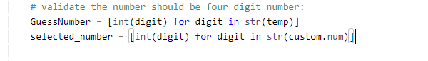

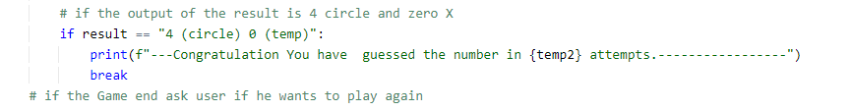

**Game Business Logic:**

i have tested the logic of the game from checking conditions, checks and correct number guessing. below is the code of that

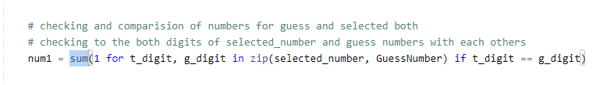

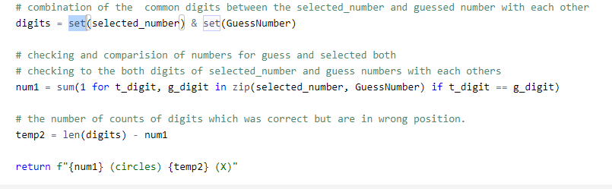

**Iteration of Game and Exit**

i have tested the iterations and exit functionality of the game

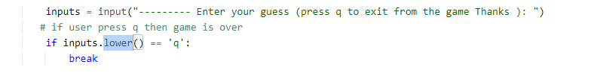

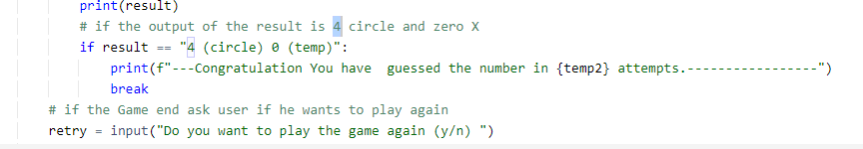

**Test Automation using the unittest Library:**

In to the software development testing holds paramount importance in guaranteeing the accuracy and dependability of your code. This framework empowers you to establish and run unit tests, thereby confirming the functionality of your code. i have tested it by importing the library of unittest. testing is the main part of any program i have tested it any end by every use case possible

below is the screenshot of the all tested inputs.

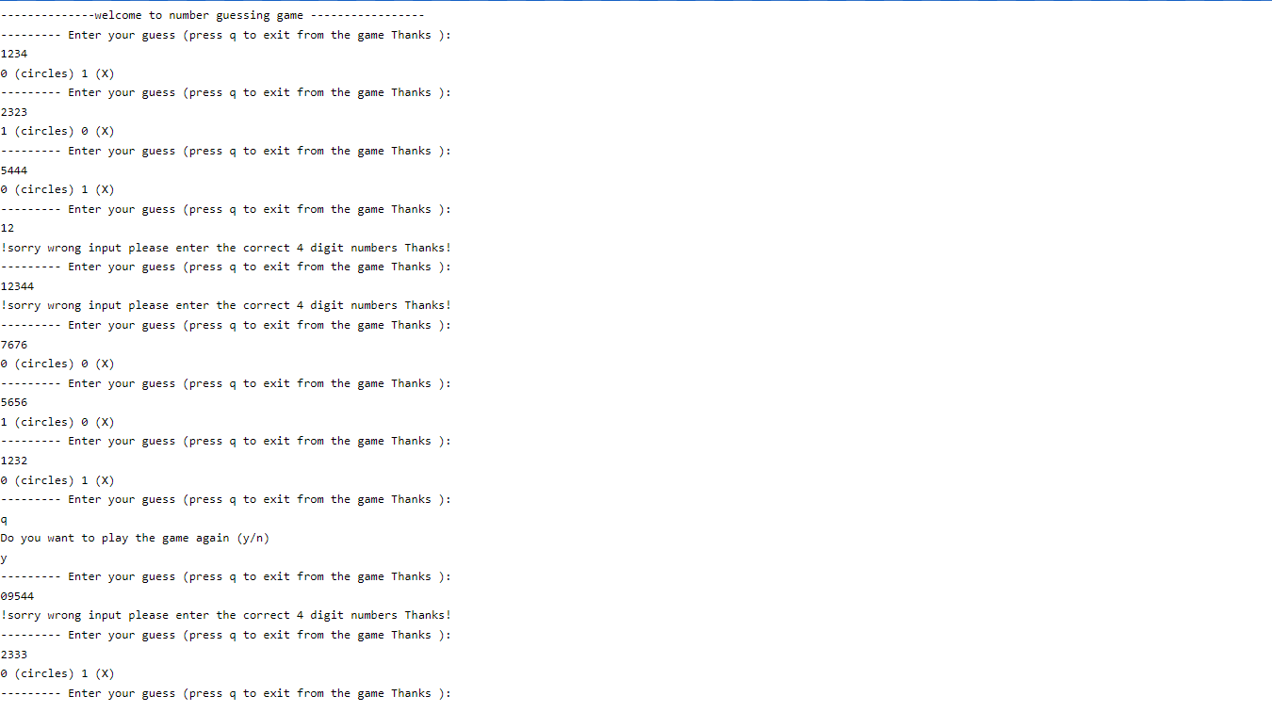

**Conclusion:**

I developed a game titled "Guess the Number" through an effective strategy known as Test Driven Development. This approach facilitated a systematic construction of the game, confirming the accuracy of each component in a gradual manner.From this project, we learned how important it is to test things thoroughly, the advantages of using TDD to guide the development process, and the value of writing code that can be easily maintained and broken into smaller parts. We used the pytest framework to make automated tests for different parts of the game. These tests could be easily run to make sure that each component of the game worked as expected

**GitHub Link**:

Please upload link